Ashish Shrestha — WP3 Individual Contribution & Progress Report
PRT661 – Data Science Practice | Dan6 Theme 2 | Modelling, Forecasting and Verification
Student | ID | WP3 role | Workstream
Ashish Shrestha | S388084 | Forecasting Lead | Random Forest A/B · chronological screening · four-month backtesting · regional selection

Evidence note This document is aligned to the verified 14 September Stage 3 run. Contribution descriptions preserve the role boundaries in the existing WP3 documents and describe shared integration as team work rather than assigning the final pipeline to one person.

1. Allocated WP3 responsibility
Ashish’s WP3 responsibility was the decision layer of the modelling pipeline: implement and test the Random Forest family, coordinate the short chronological screen, run the historical four-month comparison on identical seasonal windows, and convert the evidence into one selected production model per region. The role therefore sits between the candidate-family code supplied by all four members and the frozen forecast/verification stages supplied by Suraj and Bishal.
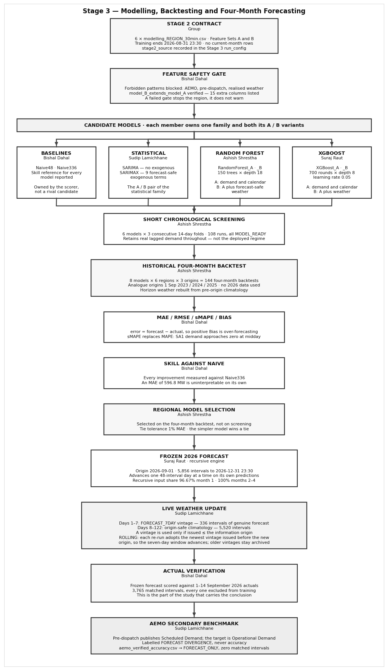
Figure 1. Final Stage 3 architecture and contribution split. Ashish owns the Random Forest branch, short chronological screening, historical four-month backtest and regional selection blocks.

2. Why Random Forest was included
Random Forest was retained because the Stage 2 dataset contains nonlinear relationships, repeated daily/weekly demand patterns, calendar variables and optional weather features. A tree ensemble can model interactions without requiring the target to be normally distributed or every relationship to be linear. Two variants were required so weather value could be tested rather than assumed: RandomForest_A uses Feature Set A; RandomForest_B uses Feature Set B.
Variant | Input contract | Purpose in comparison
RandomForest_A | 39 demand/calendar/history features; no direct future weather | Robust core model for the full four-month horizon.
RandomForest_B | 54 features; A plus 15 weather/context variables | Tests whether forecast-safe weather adds enough value to justify dependency on a weather source.

Implemented configuration Full mode uses 150 trees, max depth 18, minimum leaf size 2, sqrt feature sampling and a fixed random state. Quick mode reduces tree count/depth only for code validation; final model selection uses Full mode.

3. Short chronological screening
The screening stage is intentionally not the final competition. Six fast candidates (two seasonal baselines, Random Forest A/B and XGBoost A/B) are tested across three consecutive 14-day folds using only completed pre-2026 history. Its purpose is to detect broken or clearly noncompetitive configurations before expensive four-month recursion. SARIMA and SARIMAX are not fold-screened because their state-space fits are much slower; they remain in the full backtest.
Evidence | Verified result | Interpretation
model_screening_scores.csv | 108 rows = 6 models × 3 folds × 6 regions | Every screening run reached MODEL_READY.
screen_decision() | ML model removed only if mean screening MAE > 2× best screen MAE | Screening is a failure/efficiency gate, not a winner-selection shortcut.
2026 exclusion | Screening history stops before 1 Jan 2026 | Current-year target performance cannot influence historical winner selection.

4. Historical four-month backtesting
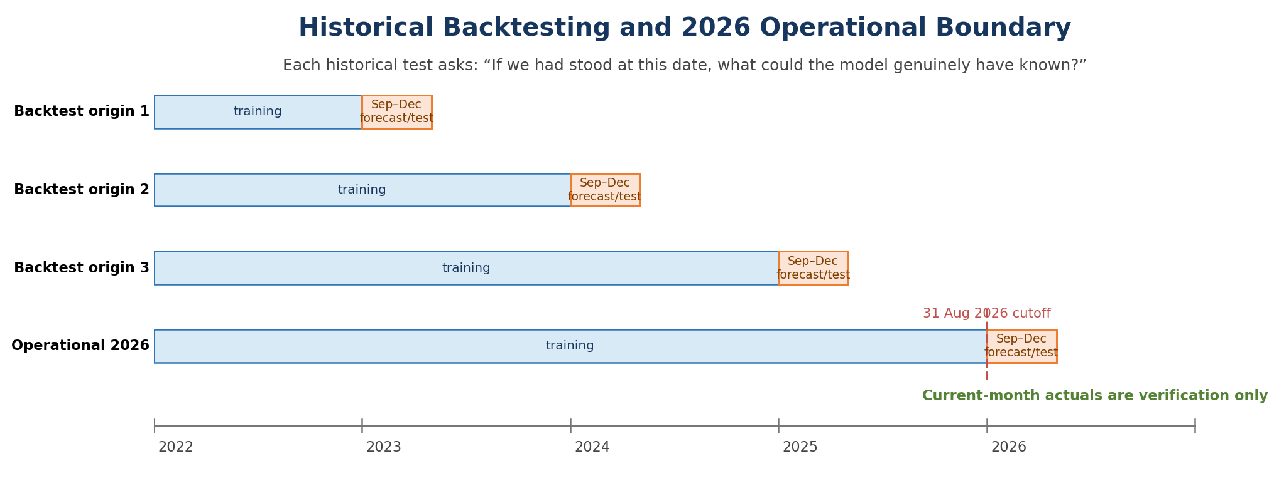
Figure 2. Historical analogue design used for the decisive model comparison. Each pseudo-origin reproduces the September–December deployment problem without using 2026 for selection.
The decisive evaluation uses 1 September 2023, 2024 and 2025 as historical forecast origins. At each origin, all eight candidates are asked to forecast the same four-calendar-month horizon. Stage 3 rebuilds origin-dependent demand profiles and weather climatology from pre-origin information, then scores predictions against the actual demand that occurred later. The full output contains 144 candidate/origin/region backtest attempts.
Backtest rule | Why it is necessary
Same four-month window for every candidate | Prevents one model receiving an easier evaluation period.
Training ends before each pseudo-origin | Prevents target leakage.
Model B target-period realised weather hidden | Prevents retrospective weather knowledge from inflating historical accuracy.
Lead bands first 7d, days 8–30, months 2–4 | Shows where error grows without changing the primary full-horizon selection rule.

5. Regional model-selection rule and actual result
Region | Selected | Set | MAE MW | RMSE MW | Skill | Origins
NSW1 | RandomForest_A | A | 596.8 | 886.1 | +27.9% | 3
QLD1 | RandomForest_A | A | 439.1 | 624.6 | +28.3% | 3
VIC1 | RandomForest_A | A | 458.2 | 641.0 | +32.2% | 3
SA1 | RandomForest_B | B | 183.1 | 273.2 | +34.8% | 2
TAS1 | RandomForest_A | A | 70.2 | 88.8 | +32.8% | 3
WA | RandomForest_B | B | 206.5 | 305.9 | +26.5% | 2

Selection is based on deployment-safe mean four-month MAE. Fully MODEL_READY candidates are preferred over warning candidates. If two candidates are within 1% MAE, the simpler and more stable option wins. This prevents an unstable model from winning because of a tiny numerical advantage. The final run selected RandomForest_A for NSW1, QLD1, VIC1 and TAS1, and RandomForest_B for SA1 and WA.
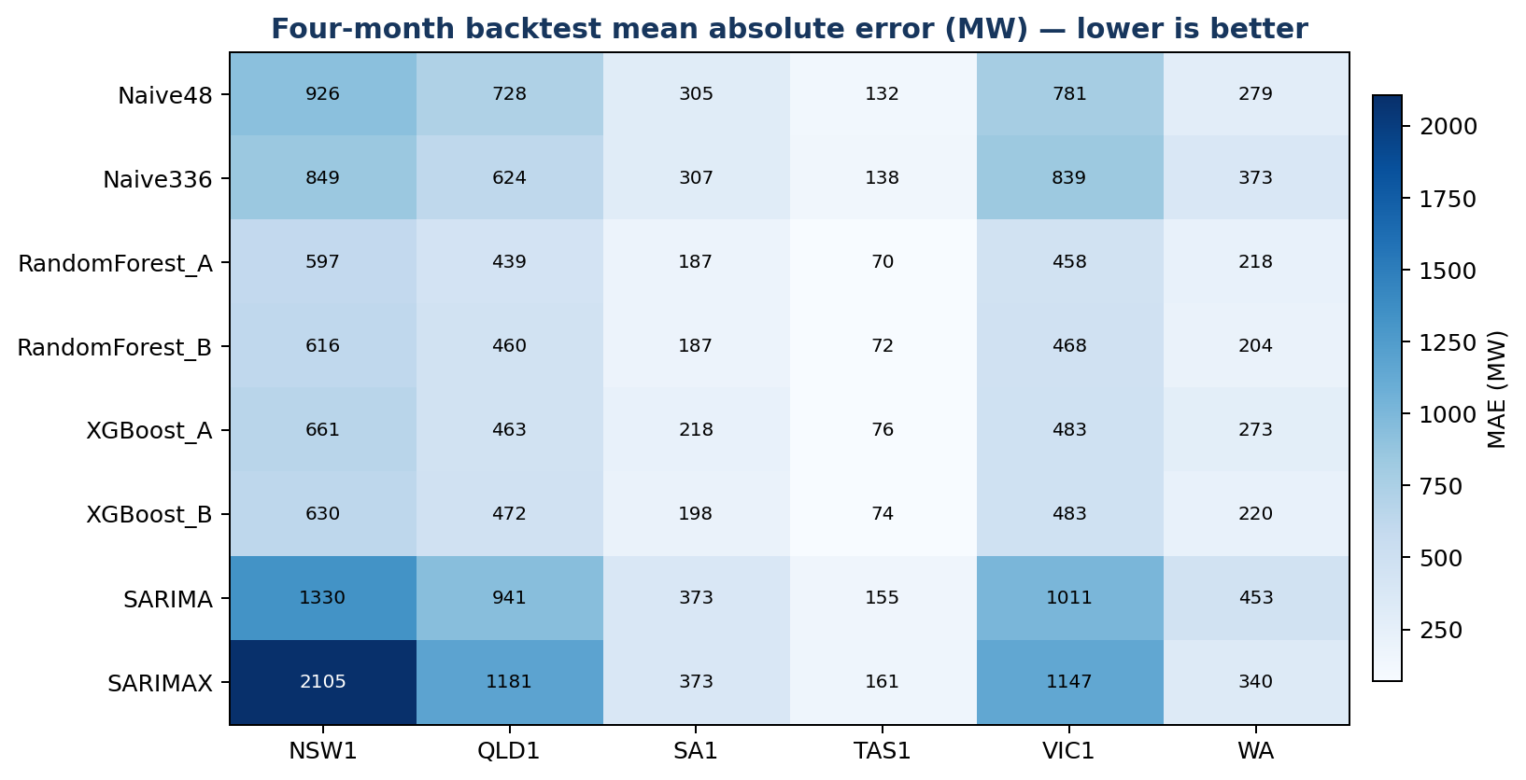
Figure 3. Mean four-month MAE across candidate models and regions. Random Forest is the strongest deployment-safe family in the final selection output.

6. Model A vs Model B interpretation
Region | A champion | B champion | A MAE | B MAE | B skill vs A
NSW1 | RandomForest_A | RandomForest_B | 596.8 | 629.0 | -5.39%
QLD1 | RandomForest_A | RandomForest_B | 439.1 | 490.8 | -11.78%
SA1 | RandomForest_A | RandomForest_B | 187.1 | 183.1 | +2.14%
TAS1 | RandomForest_A | XGBoost_B | 70.2 | 71.5 | -1.86%
VIC1 | RandomForest_A | RandomForest_B | 458.2 | 461.7 | -0.77%
WA | RandomForest_A | RandomForest_B | 218.4 | 206.5 | +5.45%

The weather experiment is mixed rather than universally positive. On the matched historical comparison, Model B improves MAE in SA1 and WA but is worse in NSW1, QLD1, VIC1 and TAS1. The team therefore treats weather as a tested feature family, not a guaranteed improvement. This result also protects the project from “feature accumulation” where more inputs are assumed to mean a better model.

7. Team collaboration and handoff
Connection | How Ashish’s work depended on it
Bishal – baselines/metrics | Screening and selection require a fixed error definition and seasonal baseline to judge whether complexity earns its cost.
Sudip – statistical/weather/AEMO | SARIMA/SARIMAX stay in the same eight-model comparison; weather-vintage rules define what Model B may see.
Suraj – XGBoost/recursion/frozen forecast | XGBoost supplies the boosting challenger; Suraj’s recursive engine makes four-month deployment behaviour honest.
Group integration | Cutoff, feature contracts and horizon are shared decisions; Ashish cannot change them independently without invalidating comparisons.

8. Code and evidence artefacts
Artefact | Contribution evidence
03_Ashish_Shrestha_RandomForest_Backtesting_Selection.py | Readable module containing RF A/B configuration, analogue origins, screening rule, deployment-safe aggregation and regional selection.
validation/model_screening_scores.csv | 108 chronological screening runs.
validation/four_month_backtest_scores.csv | 144 historical four-month backtest attempts and lead-band errors.
validation/model_selection.csv | Final regional winner and data-derived selection reason.
validation/model_A_vs_B_backtest_summary.csv | A/B weather-value comparison on historical windows.

9. Professional reflection
The strongest lesson from this work package is that model selection is an engineering decision, not a leaderboard. Screening, four-month backtesting, deployment-status filtering and tie handling all exist because a model that looks good on a short or convenient test may fail when deployed recursively for four months. The final Random Forest result is useful because it emerged from a repeatable selection rule rather than preference for a particular algorithm. The next modelling improvement should focus on per-region tuning inside the same chronological boundary, not on weakening the evaluation to produce a lower error.

